Maven Advantages

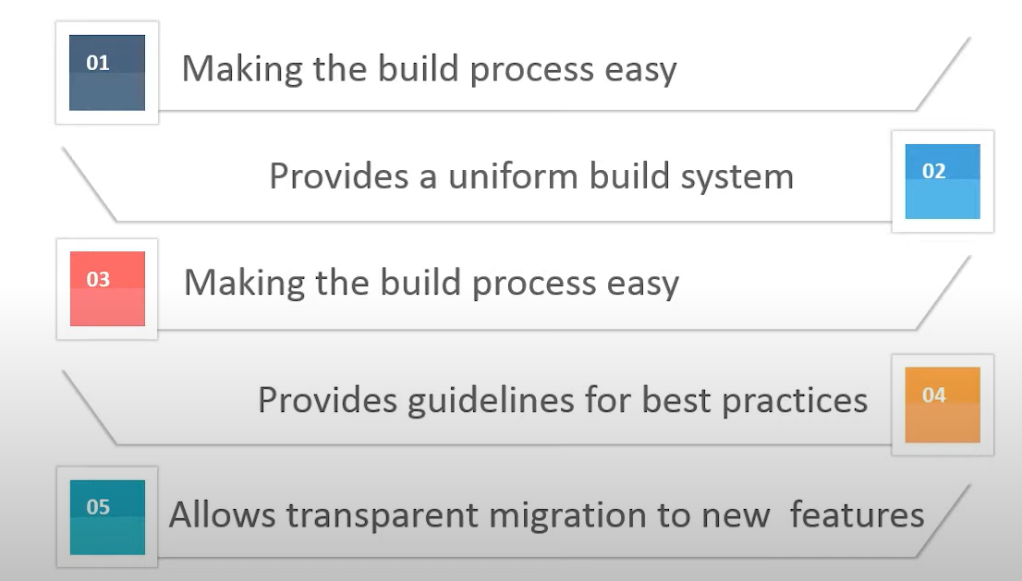

Maven Architecture

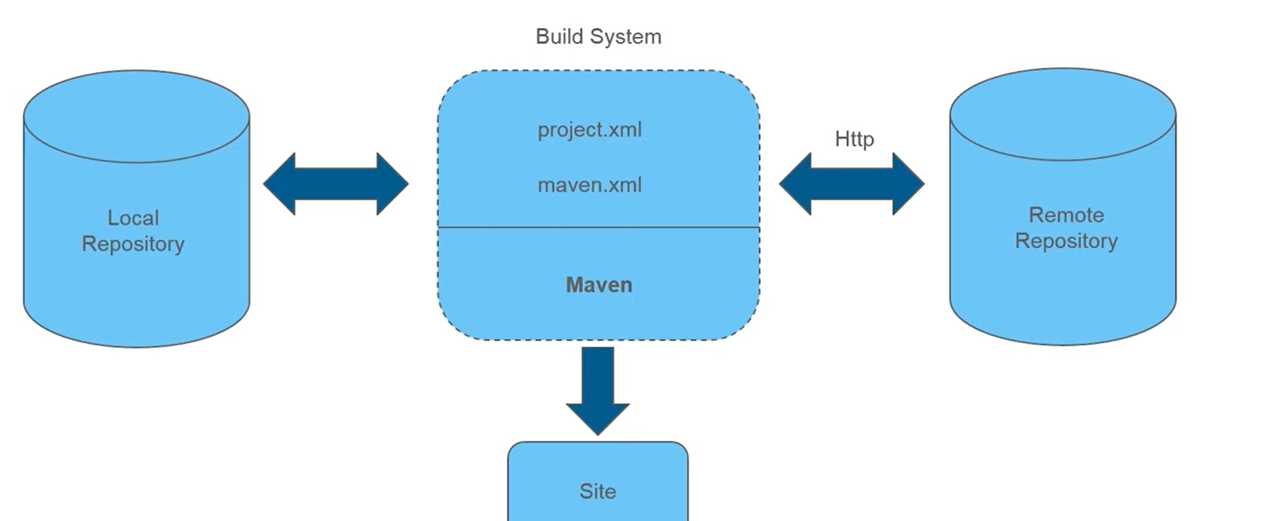

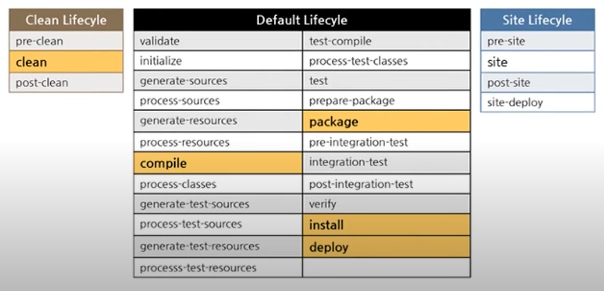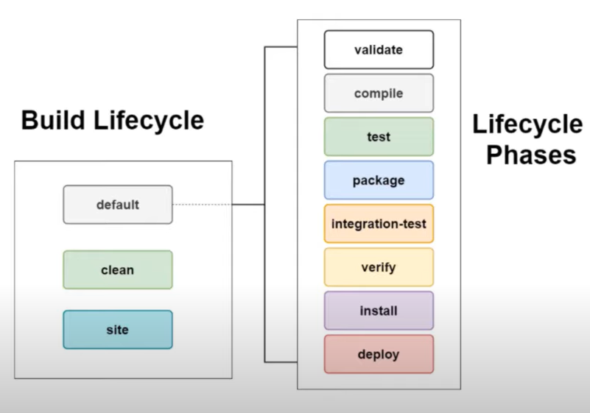

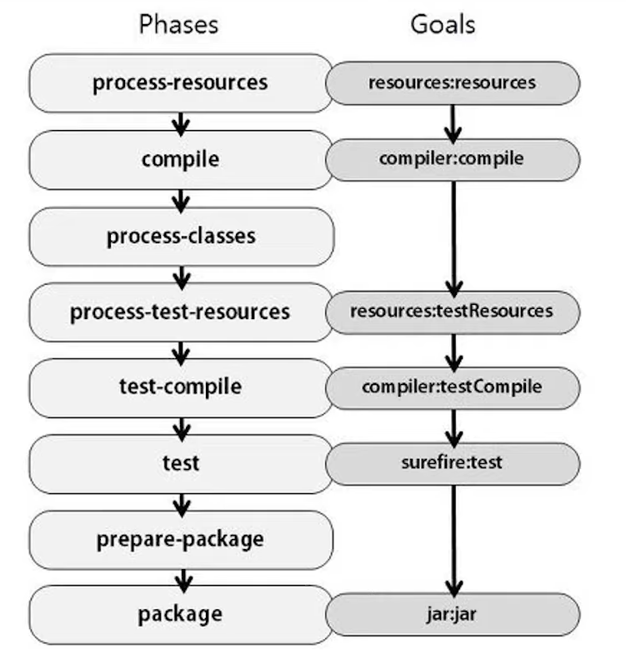

Maven Plugins

* Plugins enable us to run the lifecycle phases in our Maven Project
* Each Plugin is associated with a GOAL, which is linked to the lifecycle phase
* Plugins can be defined inside <plugin> section, under the <build> tag

Maven Compiler Plugin

* Compiles out java files, similar to running javac <java-class-name>

mvn compiler: compile

mvn compiler: testCompile

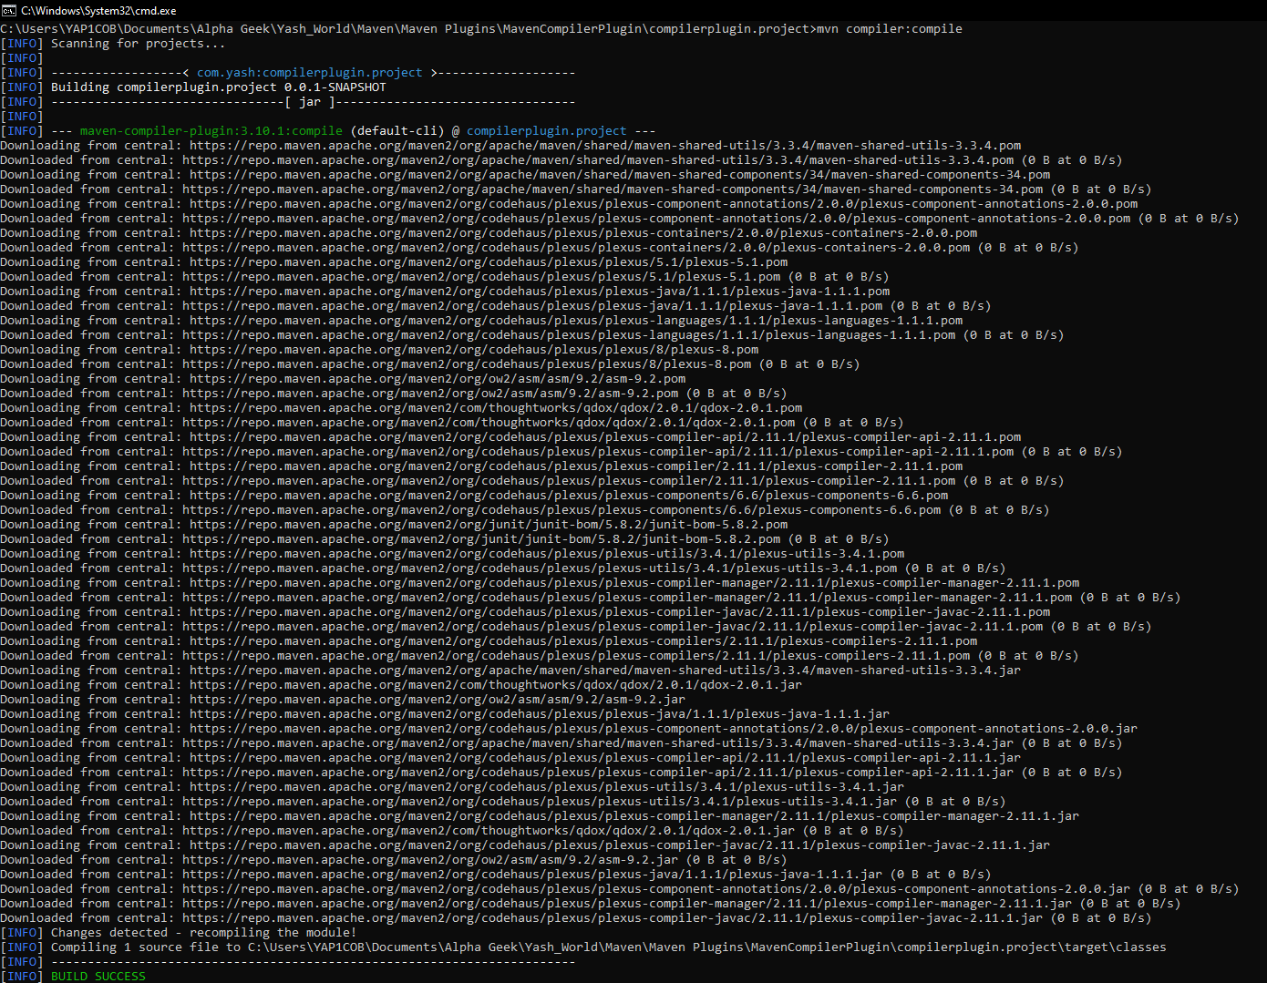

Maven Surefire Plugin

Runs Unit Test inside our Project and also generates Test Reports

mvn clean test

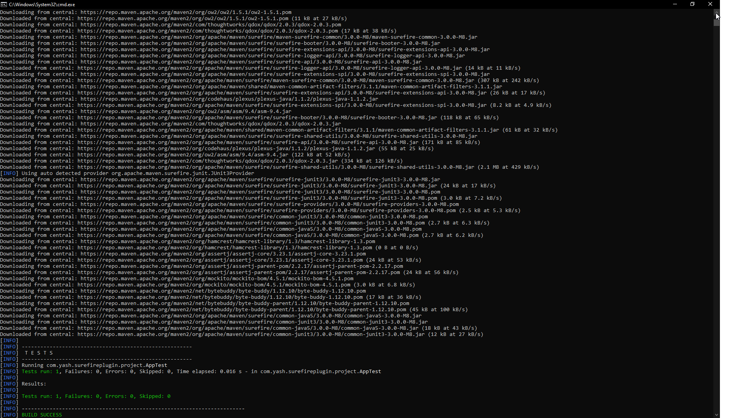

Maven Install Plugin

Packages source code into an artifact and installs it into the **Local Repository**

mvn clean install

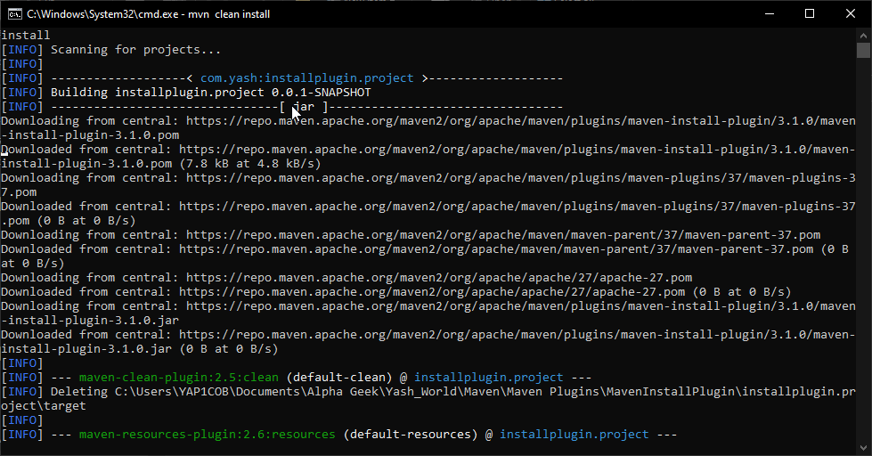

Maven Deploy Plugin

Deploys the created Artifact into the **Remote Repository**

mvn clean deploy

Maven Multi-Module Project

We have a parent project (parent POM) that contains different sub-projects (sub-modules), each of which is again a normal Maven Project.

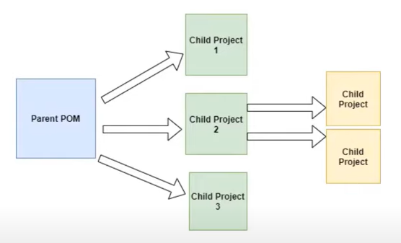

The parent POM usually encapsulates the other child’s and that’s why it is packaged as a POM instead usual packaging format of JAR.

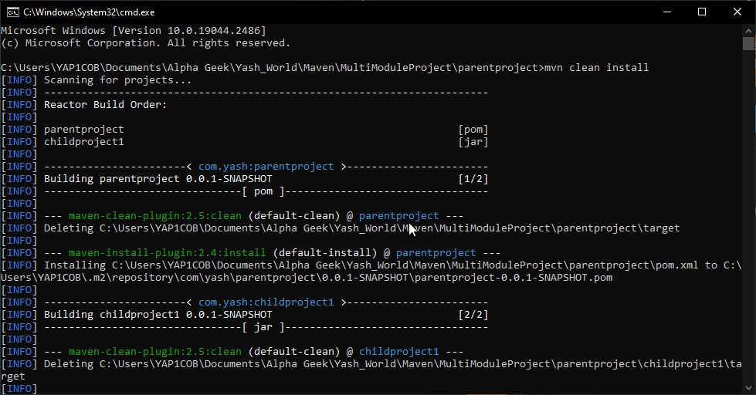

Profiles

Profiles can be used in Maven to create customized build configurations. This means customizing the behavior of our builds based on specific conditions.

mvn -Pskip-test clean install

